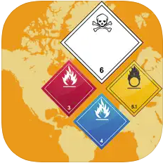 Emergency Response Guidebook 2024
First Responder
 NIOSH Pocket Guide to Chemical Hazards
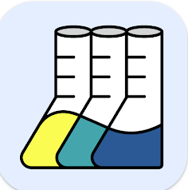 CAMEO Chemicals
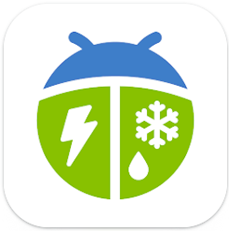 WeatherBug
ERT or IMT
 OSHA - NIOSH Heat Safety Tool
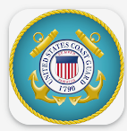 USCG Incident Management Handbook
 United States Coast Guard Boating Safety
Boat Operator

Medical
First Aid - American Red Cross (free)
Hurricane – American Red Cross (free)
Tornado – American Red Cross (free)
Earthquake – American Red Cross (free)
Pet First Aid - American Red Cross (free)
WebMD (free)
Pill Identifier - Drugs.com (free)
EMS ACLS Guide ($)
Spot a Stroke (free)
Responder Self Care (free)
FentaTIPS (free)
webPOISONCONTROL (free)
PlantSnap (free)
AIHA Heat Stress (free)

HazMat
Various Chemical Safety Data Sheets ($)
Various Chemical Periodic Tables (free)
IQ Air AirVisual (free)
Various QuickSeries Mobile ($)
Cargo Decoder (free)
Mobile REMM - Radiation Emergency (free)
DOT Chart 17 - PHMSA (free)
CAER Online - EHCMA (free)

Weather
MyRadar Weather Radar (free)
Storm Distance Calculator (free)
Dark Sky Weather (free)

Boating
Tide Graph ($)
Marine Charts ($)
Marine Tracker (free)
BoatUS – Boat Weather & Tides (free)
Navigation Rules Pro ($)
COLRegs - Rules of the Road ($)
Various Knot Guides (free)

Fire & Rescue
CMC Field Guide – CMC Rescue (free)
Williams Fire (free)

Incident Command
FIRESCOPE FOG (ICS 420-1) (free)
FEMA (free)

Utility
QR reader (free)
Aroundme (free)
Dropbox (free)
Google Translate (free)
Google Maps (free)
MapQuest (free)
Sound Meter (free)
Various Unit Converters (free)
Houston TranStar (free)
CamToPlan ($)
MYTSA (free)
Don’t Mess With Texas (free)
Microsoft Lens (free)

